**Health AI - Intelligent Healthcare Assistant**



**Team Members :-**

* **Jancy Rani.M**
* **Jothi Sowndarya.S**
* **Janani.K**
* **Gopika.P**

**Abstract:-**

This project, **Health AI – Intelligent Healthcare Assistant,** uses IBM’s Granite model with the Gradio framework to provide simple and accessible medical support. The system includes two main features: disease prediction based on user symptoms and treatment plan suggestions based on patient details such as age, gender, and medical history.

The application is built and deployed on Google Colab using Hugging Face models, making it lightweight and easy to use. While the tool offers guidance and recommendations, it highlights the importance of consulting healthcare professionals for accurate diagnosis and treatment.

By combining AI with healthcare, this project demonstrates how technology can make basic medical assistance more accessible, efficient, and user-friendly, while leaving room for future improvements like multilingual support and wider system integration.

**Project Introduction :-**

**Health AI project** typically involves designing and developing AI solutions to address key problems in healthcare through a human-centered approach that includes engagement with stakeholders such as patients, caregivers, and clinical experts. These projects aim to improve healthcare outcomes by using advanced algorithms for tasks like **disease risk prediction, early disease detection, patient monitoring, and streamlining administrative workflows.** Common applications include **AI-powered virtual assistants, remote patient monitoring, ambient sensing, automating clinical documentation, and personalized treatment recommendations.** The goal is to enhance patient care, improve efficiency, reduce costs, and support healthcare professionals with data-driven insights while addressing ethical and safety considerations.

**Project Overview:-**

Health AI uses machines to help doctors and nurses by analyzing medical data to improve patient care. It can assist with faster and more accurate **diagnoses, personalized treatments, and automating routine tasks**. Overall, AI in healthcare makes medical services smarter, faster, and more efficient.

**Pre-requisites:-**

* Gradio Framework Knowledge: Gradio Documentation
* IBM Granite Models (Hugging Face): IBM Granite models
* Python Programming Proficiency: Python Documentation
* Version Control with Git: Git Documentation
* Google Collab’s T4 GPU Knowledge: Google collab

**Key features of Health AI:-**

* Multidisciplinary collaboration involving technical experts and healthcare stakeholders.
* Use of predictive analytics to identify at-risk patients and detect diseases early.
* Integration with existing health systems and workflows for effective adoption.
* Experimentation and iterative development using feedback from users.
* Targeted applications such as AI chatbots for symptom checking, real-time vital signs monitoring, and AI-assisted clinical decision support.
* Focus on privacy, equity, and ethical implications of AI use in healthcare.

# **System Requirements :-**

* Google Colab (T4 GPU enabled)
* Python 3.x
* Libraries: transformers, torch, gradio.
* Python, Hugging Face, GitHub.

# **System Design & Architecture**

# The Health AI – Intelligent Healthcare Assistant is designed to integrate natural language processing (NLP) with an easy-to-use interface to assist users in predicting diseases and generating treatment plans. The architecture combines front-end interaction through Gradio with back-end AI processing using the IBM Granite model.

## **1. System Architecture**

# The system follows a modular design:

# User Layer (Input/Output): Users provide symptoms or health condition details through the Gradio interface.

# Processing Layer (AI Model): IBM Granite model (via Hugging Face) processes the input, interprets medical terms, and generates predictions or treatment suggestions.

# Application Layer (Business Logic): Python functions handle disease prediction and treatment plan generation.

# Output Layer (Results): Processed results are displayed in the Gradio UI with proper disclaimers for medical safety.

# 

## **2. Data Flow Diagram (DFD)**

# Level-0 DFD (High-level view):

# User enters symptoms/condition.

# System processes input using tokenizer + AI model.

# Predictions/treatment plans are generated.

# Output is shown back to user.

# 

## **3. Use Case Diagram**

# Actors involved:

# User (Patient): Inputs symptoms/condition.

# System (Health AI): Processes input, predicts disease, generates treatment plan.

# Use cases:

# Symptom-based disease prediction.

# Condition-based treatment suggestions.

# Display disclaimer to emphasize medical consultation.

# 

## **4. Summary**

# Input Collection: User enters symptoms or condition details.

# Processing: AI model analyzes input using pre-trained knowledge.

# Prediction/Recommendation: System generates possible diseases or treatment plans.

# Output Display: Results are shown in a clear and user-friendly format through Gradio.

# 

# 

# **Project Workflow :-**

# **Exploring Naan Mudhalvan Smart Interz Portal**

1. Search for 'Naan Mudhalvan Smart Interz' portal in any browser.

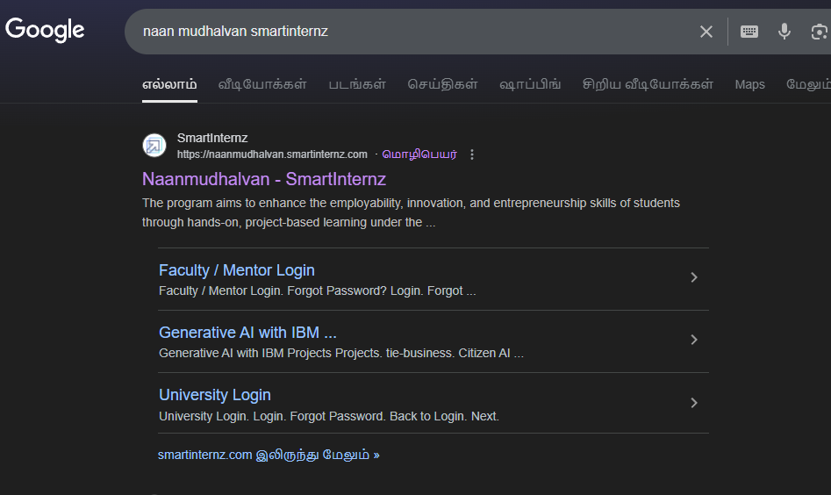

2. Login with your details.



3. Go to 'Projects' section and select 'Health AI'.

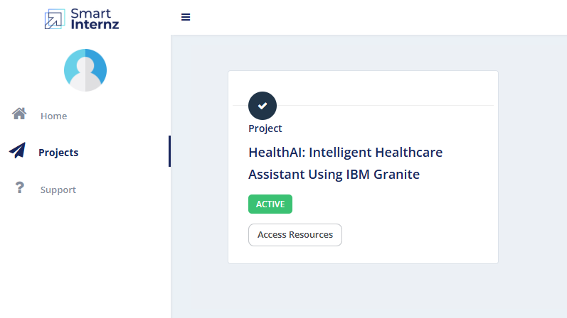

4. Access resources and guided project.

5. Navigate to project workspace to track progress.

## 

## **Choosing IBM Granite Model (Hugging Face)**

1. Visit Hugging Face and create an account.  
2. Search for 'IBM-Granite models'.  
3. Choose a model (here: granite-3.0-2b-instruct) for fast and lightweight performance.

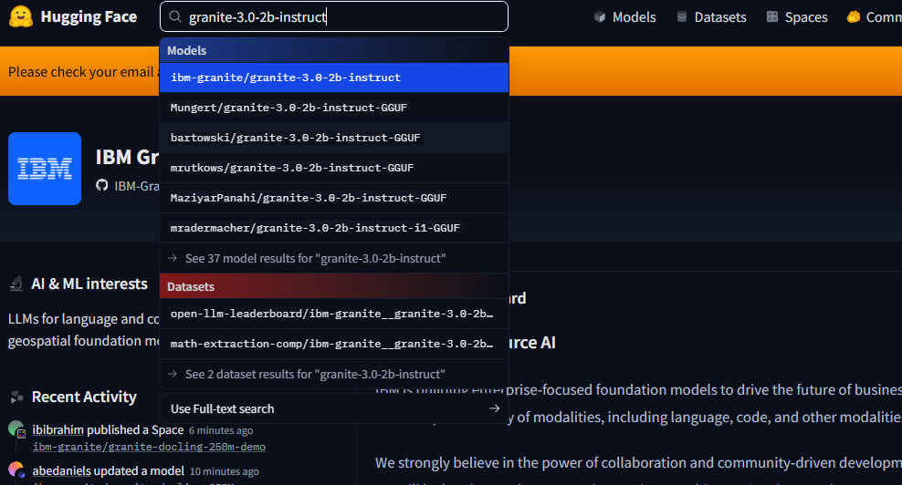

**Running in Google Colab**

1.Open Google Colab and create a new notebook.  
2.Change runtime type to T4 GPU.  
3. Install required libraries using.

**!pip install transformers torch gradio -q**



4.Run the Health AI code from provided source.

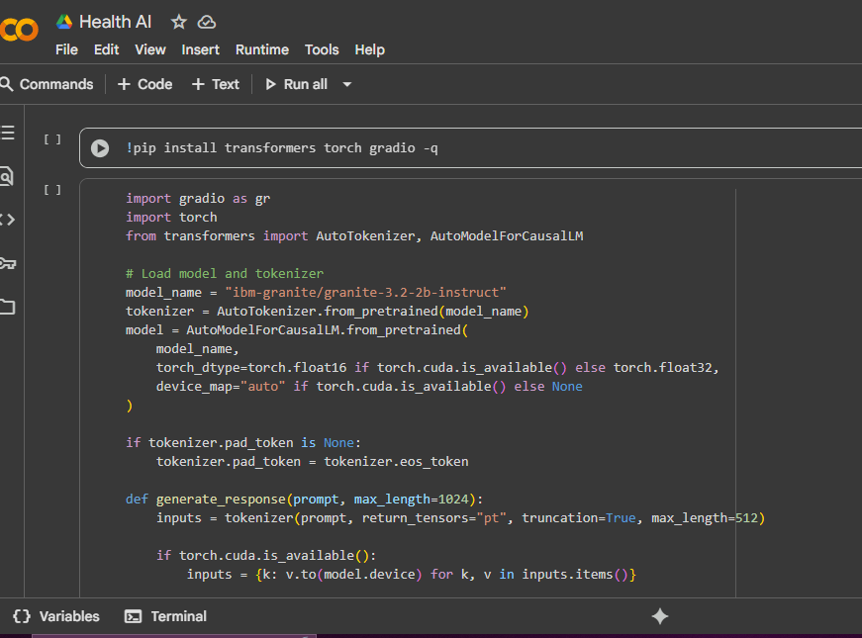

You can find the code in this link: [HealthAI](https://drive.google.com/file/d/1P1OLDHcLNybn7VAR2WocUnx9L0-u_uMm/view?usp=drivesdk)

5.Launch the Gradio application and test the output.

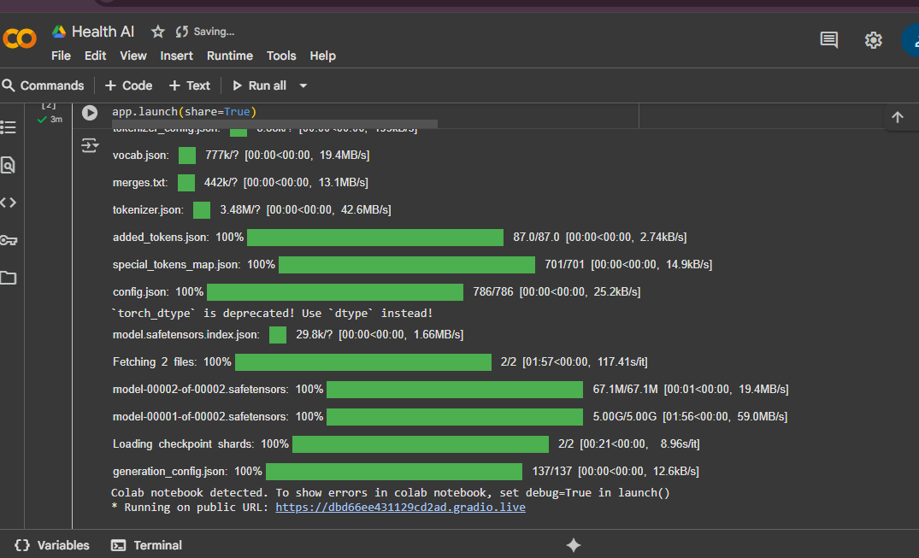

## **Here is the output link:-** [**https://565990d85fd45c5ef1.gradio.live**](https://565990d85fd45c5ef1.gradio.live/)

## 

## **Uploading to GitHub**

1.Create a GitHub account and repository.  
 2. Download project code from Google Colab.

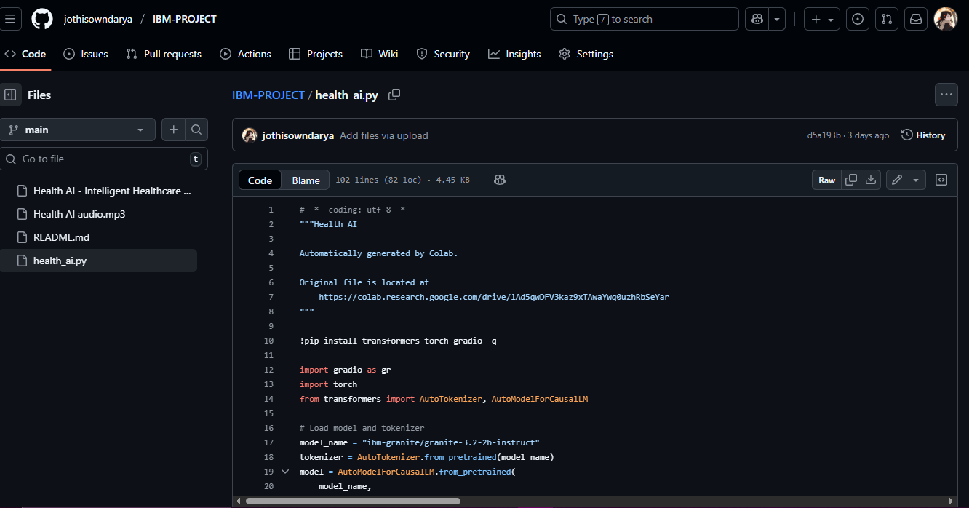  
 3. Upload files to GitHub repository.  
 4. Commit changes and share repository link.

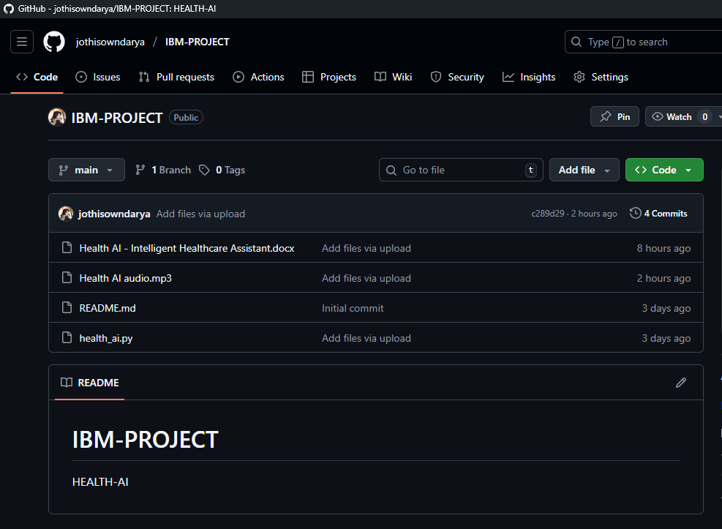

# 

# **Challenges Faced**

* Model loading time in Colab due to large model size.
* GPU runtime limits in free Colab tier.
* Initial learning curve for Hugging Face and Gradio integration.

## output:-

## 

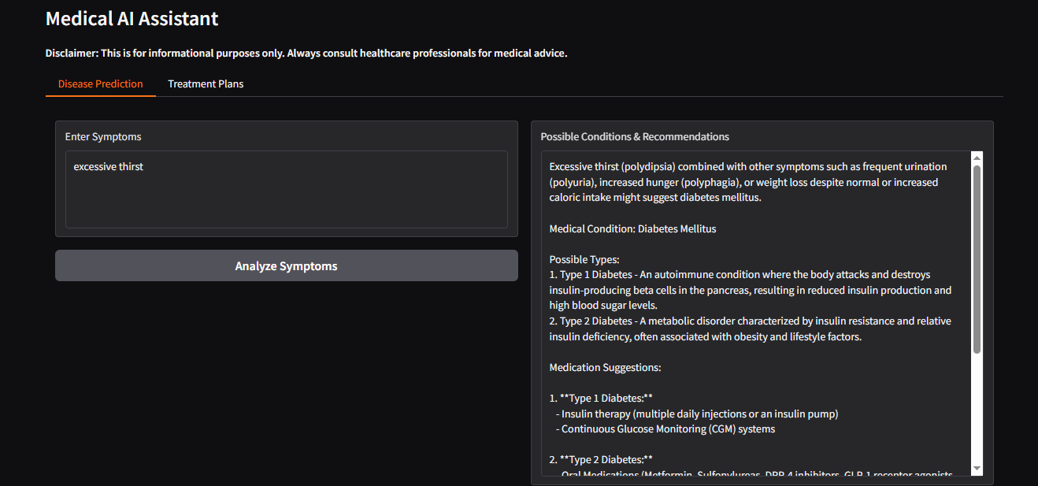

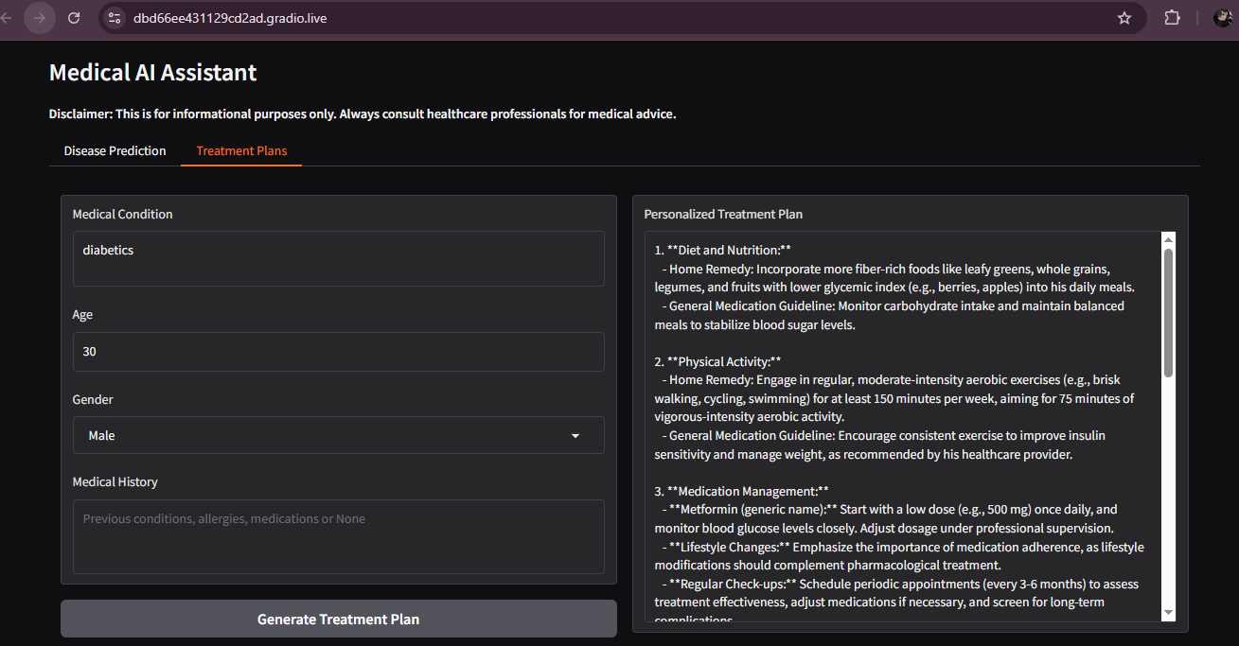

# 

# **Conclusion :-**

The project **Health AI – Intelligent Healthcare Assistant** demonstrates the potential of artificial intelligence in making healthcare support more accessible and efficient. By integrating IBM Granite models with Gradio, the system provides two key features: **disease prediction based on symptoms** and **personalized treatment plan suggestions**. The project highlights how AI can assist patients by offering quick, data-driven insights while emphasizing the importance of professional medical consultation.

Through implementation in Google Colab, the solution remains lightweight, cost-effective, and easy to deploy. Despite challenges such as model size, GPU limitations, and the ethical concerns of using AI in healthcare, this project successfully proves that AI-driven tools can support healthcare professionals and empower patients with basic guidance.

In the future, the system can be enhanced with features such as **multilingual support, voice-based interaction, integration with hospital databases, and advanced predictive analytics**. Such improvements would further expand its scope and impact, moving closer to real-world clinical applications.